pgEd Goes to the Library:

What is genetic discrimination?

What is genetic discrimination? What are my rights? How can I know if it happens to me, and what should I do if it does? Where can I learn more?

1. Watch a video from Representative Louise Slaughter describing genetic discrimination and the law she worked to pass to prevent it, The Genetic Information Nondiscrimination Act.

https://www.youtube.com/watch?v=zmRqOK-sawE

2. Confident you understand the issues? Great! Take a 5 question quiz and pin yourself on our world map – in addition to genetic discrimination, we have quizzes on basic ideas in genetics, Ebola, and Alzheimer’s Disease

www.pged.org/map-ed/

3. Put yourself in the shoes of a small business owner making a difficult hiring decision. How does your plan of action match up with the others considering this case?

http://www.nature.com/scitable/forums/genetics-generation/case-study-in-genetic-discrimination-106704416

4. Want to learn more? Genetic discrimination in the news, impacting amateur and professional athletes:

In NCAA, A Question of Bias Over a Test for a Genetic Trait, New York Times, by Katie Thomas and Brett Zaandam April 11, 2010
http://www.nytimes.com/2010/04/12/sports/12sickle.html?pagewanted=all

Baseball’s Use of DNA Raises Questions, New York Times, by Michael Schmidt and Alan Schwarz, July 21, 2009

http://www.nytimes.com/2009/07/22/sports/baseball/22dna.html

5. Join us for a book discussion:

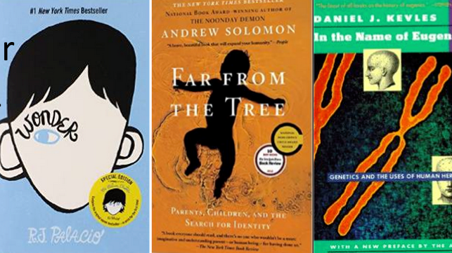

www.pged.org - Personal Genetics Education Project

