A POCKET SOLAR SYSTEM
- Steps to a “pocket solar system”
- Cut 4 foot lengths of 2” wide roll paper, (for calculators/registers), for each person
- 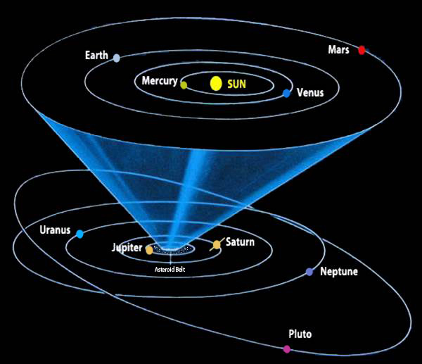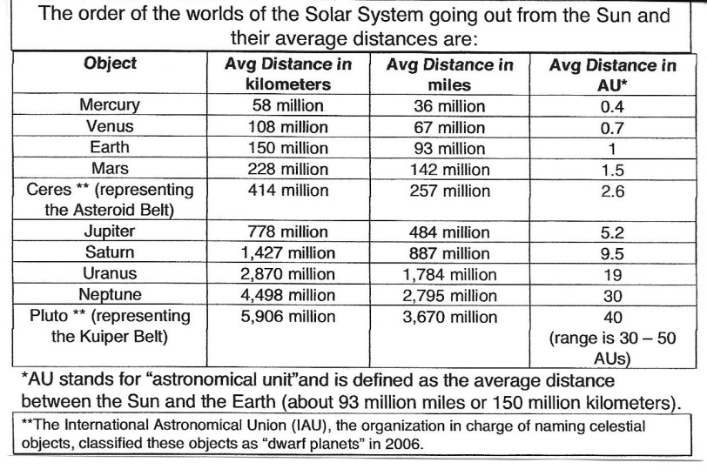
- Use the above chars for reference and distance information from the SUN.
- At one end of the 4 ft. strip write: “SUN” and on the bottom write: “PLUTO/Kuiper Belt”
- Fold the strip in half, Sun to Pluto and make a crease. On the first fold, write URANUS.
- Fold the strip in half and fold in half again. (quartered)
- Write the name of the planet on the fold between URANUS and PLUTO. (NEPTUNE)
- What is the planet on the orbit/fold, halfway between URANUS and the SUN? (SATURN)
- Fold the SUN in SATURN’s orbit/fold and make a new crease.
- What is halfway between SATURN and the SUN? (JUPITER)
- Fold the SUN to the orbit/fold of JUPITER and make a new crease.
- What is halfway between JUPITER and the SUN? (ASTEROID BELT)
- Fold the SUN to the orbit/fold of the ASTEROID BELT and crease. What’s the next Planet? (MARS)
- Fold the SUN to MARS’s orbit/fold and crease…fold in half and crease again. Open to 3 new creases.
- From MARS, write E EARTH; from EARTH, write V VENUS; from VENUS, write M MERCURY (image)
- 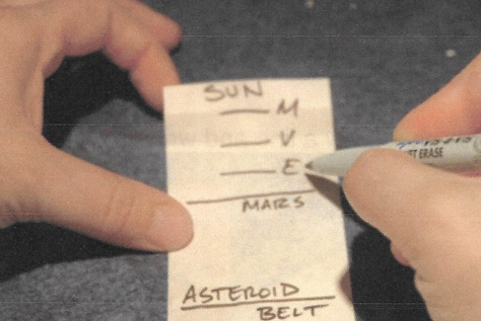 These four inner planets are the “ROCK” Planets
- The outer four Planets are the “GAS GIANTS”. PLUTO is a “Dwarf” Planet, mostly of rock.
- The distance chart at #3 describes the “ASTRONOMICAL UNIT” as 93 million miles, the average distance from the SUN to the EARTH or 1 AU. Mark the AU’s for each orbit/fold per Planet. PLUTO orbits from 30 to 50 AU’s as it clips NEPTUNES orbit and passes through the KUIPER BELT.
- At this scale, the nearest STAR from our SUN is Alpha Centauri, 6 miles away…4.2 Light Years. A LIGHT YEAR is approx. 6,000,000,000,000 miles, (6 TRILLION). The speed of light is 186,000 miles per second. SUNLIGHT takes 8.33 minutes to reach EARTH and 4 hours, 15 min. to reach NEPTUNE!

